**Abstract:**

Shafts which are of great significance in power transmission are supported by bearings. Because of its versatility in supporting and applying the load on the shaft by reduced friction, Journal bearing is widely used in automobile and aerospace industries. This research work mainly investigates about calculation of energy dissipation by placing bumps in journal bearing. Modified form of Reynold’s equation determines the amount of energy dissipated. When bump is placed, vibration is effectively controlled due to increased energy dissipation. The modified Reynolds Equation is solved by Numerical Methods with appropriate boundary condition. This paper uses the finite difference method to calculate the distribution of hydrodynamic pressure in the radial bearing. In Finite difference method, the derivatives or gradients are replaced by simple difference formula. It is a method of discretization process where the entire bearing space is divided into an M*N grid system. The pressure values at every node is initialized with certain value, and are updated on every iteration subsequently. Although the numerical methods for solving the Reynold’s equation are accurate and efficient enough for arriving at the result, this work aims at the MATLAB solution of Reynolds equation.

**Introduction:**

It is very important to look deeply into the performance characteristics of bearings and this research mainly aims at normalising the Reynold’s equation to calculate the energy dissipation by placing the bumps.

The bump supports the top foil, and acts as a spring, hence the bearing is known as compliant over the bump bearing. A thin smooth top foil sheet, is placed over the bump foil, now these foils are connected mostly by welding at one of the ends known as leading edge and are open at the other end, called the trailing edge.

A positive pressure is developed in the oil film if the volume of the lubricant, which is dragged into the space, being greater than that is being discharged. The film developed is nothing but the converging film.

When N=0, there is metal to metal contact, between journal bearing and forms boundary film lubrication. As the speed picks up, the positive pressure is developed, and forms mixed film lubrication. When the journal speed reaches to its fullest, sufficient pressure is developed in the converging part of fluid film and lifts the journal thereby maintaining the minimum oil film thickness going into hydrodynamic (full film) lubrication.

**2. Derivation of Reynolds eqn.:**



The velocity is given by

$u=\left(\frac{y^{2}-yh}{2*η}\right)\frac{∂p}{∂x}+\left(u_{1}-u_{2}\right)\frac{y}{h}+u_{2}$

The second order differential equation is given by

$$\frac{∂}{∂x}\left(h^{3}\frac{∂p}{∂x}\right)+\frac{∂}{∂z}\left(h^{3}\frac{∂p}{∂z}\right)=6ηU\frac{∂h}{∂x}$$

Methodology to solve the problem statement is given by

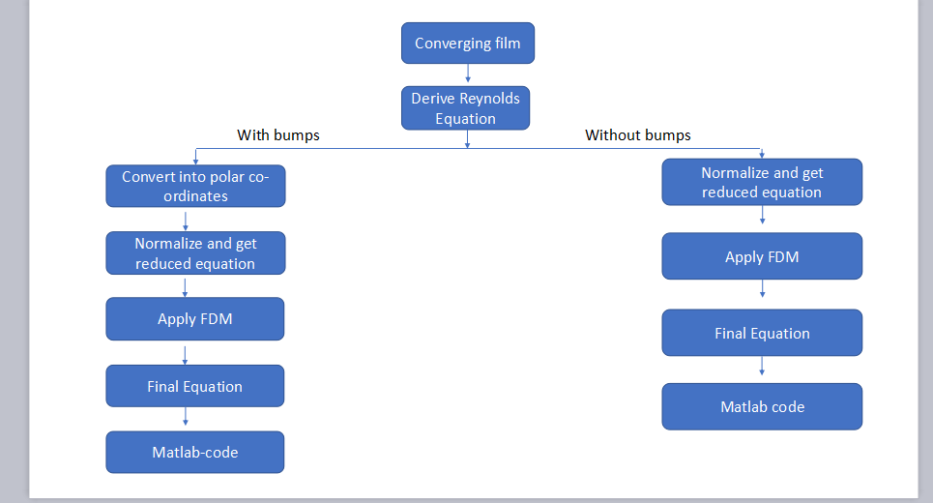

**Case 1:- without placing the bumps:**

On making the modifications to the Reynolds equation, we get

$\frac{∂}{∂x}\left({\overline{h}}^{ 3}\frac{∂p}{∂x}\right)+(\left(\frac{x}{z}\right)^2)\frac{∂}{∂z}\left({\overline{h}}^{ 3}\frac{∂p}{∂z}\right)=\frac{C}{x}\frac{∂\overline{h}}{∂\overline{x}}$

On normalising and applying FDM, we get

p(I,J) = A* p(I,J+1) + A* p(I,J-1) + C* p(I+1,J) + D* p(I-1,J) – E

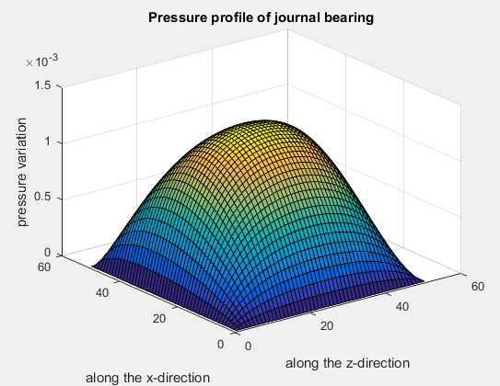

**Case 2:- with placing the bumps:**

The Reynolds equation in polar co-ordinates is

$$\frac{1}{θ} \frac{∂}{∂r}\left(h^{3}\frac{∂}{∂x}\left(\frac{∂p}{∂r}\frac{1}{θ}+\frac{∂p}{∂θ}\frac{1}{r}\right)\right)+ \frac{1}{r} \frac{∂}{∂θ}\left(h^{3}\frac{∂}{∂x}\left(\frac{∂p}{∂r}\frac{1}{θ}+\frac{∂p}{∂θ}\frac{1}{r} \right)\right)=6ηwR\frac{∂}{∂x}\left(\frac{∂h}{∂r}\frac{1}{θ}+\frac{∂h}{∂θ}\frac{1}{r}\right)$$

On normalising and applying FDM

$$p_{i,j}=A_{i,j }{\overline{p}}_{i,j}+B_{i,j}{\overline{ p}}_{i,j+1} +C_{i,j}{\overline{ p}}_{i+1,j}+D_{i,j}{\overline{ p}}_{i-1,j}+E$$

$$Where$$

$A=\frac{\left(\frac{{{\overline{h}}^{3}}_{i+0.5,j}}{θ^{2}{∆\overline{r}}^{2}}+\frac{{{\overline{h}}^{3}}_{i,j+0.5}}{∆θ\overline{ r }∆\overline{r} θ}\right)}{K}$ $B=\frac{\left(\frac{{{\overline{h}}^{3}}_{i+0.5,j}}{θ^{2}{∆\overline{r}}^{2}}+\frac{{{\overline{h}}^{3}}_{i,j+0.5}}{∆θ\overline{ r }∆\overline{r} θ}\right)}{K}$ $C=\frac{\left(\frac{{{\overline{h}}^{3}}_{i-0.5,j}}{θ^{2}{∆\overline{r}}^{2}}+\frac{{{\overline{h}}^{3}}_{i,j-0.5}}{∆θ\overline{ r }∆\overline{r} θ}\right)}{K}$ $D=\frac{\left(\frac{{{\overline{h}}^{3}}_{i-0.5,j}}{∆θ\overline{ r }∆\overline{r} θ}+\frac{{{\overline{h}}^{3}}_{i,j-0.5}}{{∆θ}^{2} {\overline{r}}^{2}}\right)}{K}$

$$E=\frac{-B\left(\frac{{\overline{h}}_{i+1,j}-{\overline{h}}_{i-1,j}}{2∆\overline{r}θ}+\frac{{\overline{h}}_{i,j+1}-{\overline{h}}_{i,j-1}}{2r∆θ}\right)}{K}$$

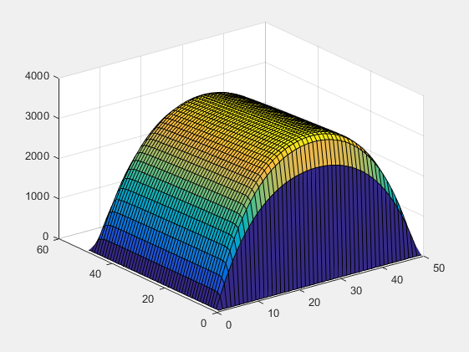

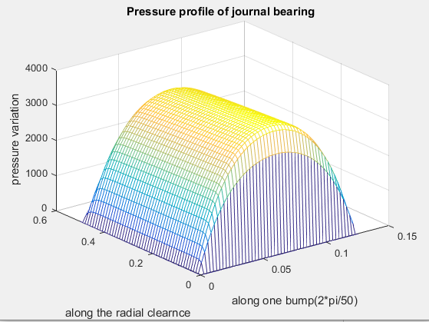

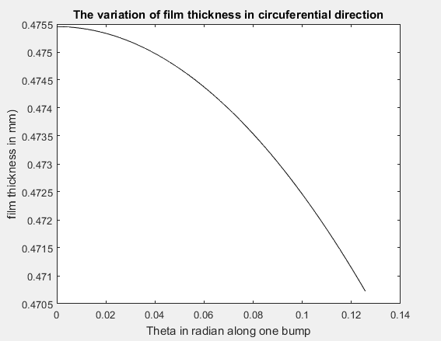

### Calculation of Energy Dissipation: -

Three types of mechanical dissipation are present in an elastic compliant bearing structure they are Viscous damping, Structural or hysteretic damping and Coulomb friction damping

1. Stiffness Coefficient, $K_{D}=\left(\frac{F cos∅}{x}+4ω^{2}\right)\left(\frac{1}{100}\right)$ KN/M
2. Damping Coefficient, $C=\left(\frac{F sin∅}{ω x}\right)\left(\frac{1}{100}\right)$ NS/M
3. Stiffness Coefficient, $K_{D}=\left(\frac{F cos∅}{x}+4ω^{2}\right)\left(\frac{1}{100}\right)$
4. Damping Coefficient, $C_{eq}=\left(\frac{F sin∅}{ω x}\right)\left(\frac{1}{100}\right)$
5. Angular velocity $ω$ = 2piN/60
6. Excitation frequency= $ω$/2pi
7. Force $F=mω^{2}e$
8. Damping Coefficient, $C_{eq}=\left(\frac{F sin∅}{ω x}\right)\left(\frac{1}{100}\right)$
9. Energy dissipated E = kγπx2

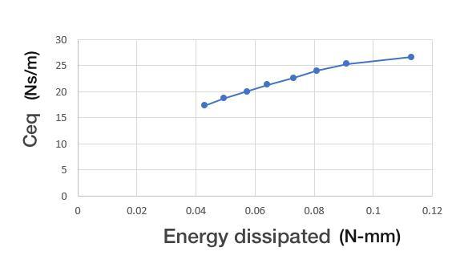

Energy diss vs ceq

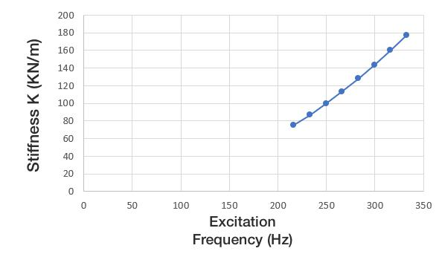

### 

### Conclusions

Reynolds equation is modified for two cases, i.e. by placing bumps and without placing it. It is modified using normalization technique and finite difference method and related graphs are obtained. For the above cases, pressure distribution is analysed and we obtain a result of higher pressure in the case of bumps placed. Energy dissipation is calculated in each case and the respective graphs are obtained. This infers that by placing the bumps the load carrying capacity and damping is increased, thereby achieving the controlled vibrations. The complexity of tribological phenomena is so large that without the use of computer technology it is difficult to make any research in this area. Computer technology that uses advanced numerical methods is a supportive tool, in many cases it allows to carry out modelling and simulation of complex tribological occurrence which take place in different nodes and different working conditions. Effective vibration control is the research outcome of this paper

### References

1. Campbell, W.E. (1969). “Boundary Lubrication: An Appraisal of World Literature.” ASME.
2. Shims Robert Hoffmann1 Tomasz Pronobis1 Robert Liebich SIRM 2015 – 11th International Conference on Vibrations in Rotating Machines, Magdeburg, Deutschland, 23. – 25. February 2015 A numerical performance analysis of a gas foil bearing including structural modifications by applying metal
3. P. N. Nagare Department of Mechanical Engineering, Amrutvahini College of Engineering Sangamner, India

A Comparative Study on Numerical Solution of Reynolds Equation of Journal Bearing

1. Malcolm E. Leader, P.E Co. Durango, Colorado, Applied Machinery Dynamics Understanding Journal Bearings
2. L. P. Alford, McGraw Hill, The American Machinist, 1911 Bearings and Their Lubrication
3. Wiesław Graboń, Jan Smykla, Computer program for simulation of pressure distribution in the hydrodynamic radial bearing
4. D. Sfyris a, A. Chasalevris b, University of Aegean, Aegean 81400, Greece

An exact analytical solution of the Reynolds equation for the finite journal bearing lubrication

1. https://www.tandfonline.com/doi/abs/10.1080/10402004.2010.538490